Installation Guide

As this project we only used to demonstrate the functionality of front-end which is not required a database to host the actual data table. So, in theory it could be opened on client local machine. However, so Google Chrome doesn’t support the local cookies feature, so we recommend using Firefox for the testing environment.

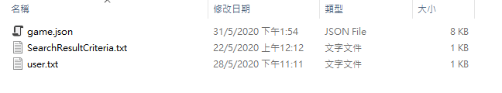

This website support little degree of dynamic generated content without server code, there are 3 files named “game.json”, “searchResultCriteria.txt” and “user.txt” which will be introduced in the corresponding function page.

**If you would like to change the content of the file to reflect to the page. You should change the file path in the corresponding JavaScript file placed in js folder to your hosting (We suggest using Git Hub).**

changeinformation.js:



Detail.js



Index.js



SearchResult.js

